Texas Equitable Access Roadmap: A Toolkit to Support Texas Districts to Develop Local Equitable Access Plans

Introduction
In 2014, the U.S. Department of Education launched the Excellent Educators for All initiative to support states and districts in ensuring that students of color and low-income students have equitable access to excellent educators. All 50 states submitted equitable access plans, documenting the equity gaps that students in their state faced, the results of a root cause analysis conducted to better understand the causes of these equity gaps, and plans to implement strategies to close equity gaps and monitor progress of implementation. In December 2015, Congress passed the Every Student Succeeds Act (ESSA), which requires states and districts to determine whether low-income students and students of color in Title I schools are served at disproportionate rates by ineffective, out-of-field, or inexperienced teachers, and take steps to address any identified disproportionalities (i.e., gaps in equity).
To support Texas districts in better understanding and addressing the challenges they face in providing equitable access to excellent teachers for the students who need it most, the Texas Education Agency (TEA) has developed the Texas Equitable Access Roadmap: A Toolkit to Support Texas Districts to Develop Local Equitable Access Plans. The Roadmap will take district teams through a series of processes to understand, interpret, and implement an action plan around equitable access. Please note all of the tools include links to additional resources and materials. Please visit the Appendix at the end of this document for a list of the linked resources throughout all of the tools, by topic. The Appendix provides a “one stop shop” to easily access the resources.

Putting It All Together: The District Roadmap Reporting Template
The overview of the five steps can be found here, with links to the resources for each step of the process. This document provides an overview of the five steps in the toolkit, along with a centralized reporting template for districts to document the findings of their equity planning.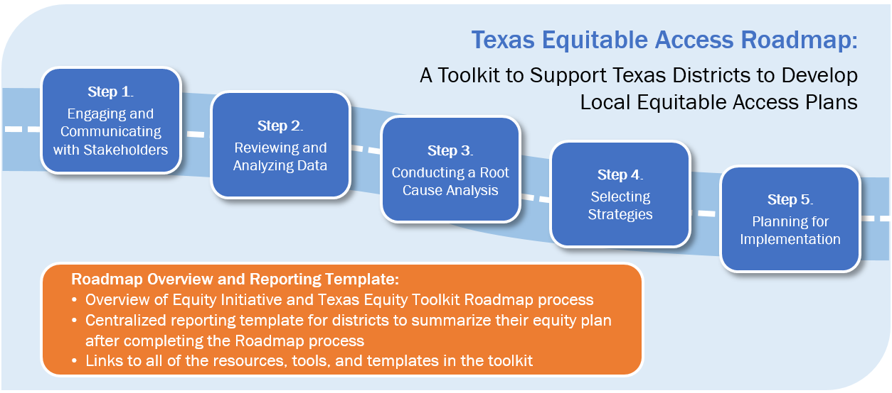
Purpose
As you complete each step in the Roadmap (i.e., Engaging and Communicating with Stakeholders, Reviewing and Analyzing Data, Conducting a Root Cause Analysis, Selecting Strategies, and Planning for Implementation), you will be asked by TEA to summarize the key takeaways developed while engaging in the processes involved with each tool. This resource provides a space where you and other district staff can transfer content (through the “copy/paste” process in Microsoft Word) from each tool into a centralized Roadmap Reporting Template located at the end of this document. The reporting template will provide a simple way for you to summarize your district’s equity plans and submit them to your local education service center (ESC).
Following is a brief description of the tools to help remind you of the steps and processes you undertook when developing your district’s equity plan. At the end of this document, you will find the District Reporting Template along with instructions on how to complete the template.

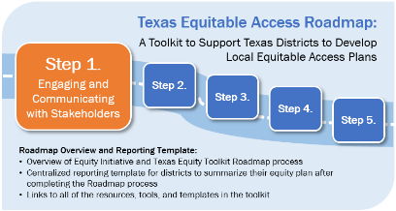
Step 1. Engaging a Communicating with Stakeholders
Engaging and communicating with stakeholders helps establish buy-in and participation from your education community in your equity planning development. By involving stakeholders, you have determined critical strategy decisions in a collaborative way and have defined with stakeholders what equitable access should look like in your district.
After completing the Engaging and Communicating with Stakeholder work in Step 1, your district will have:
- Built a district team to lead and be responsible for stakeholder engagement and communications,
- Identified stakeholders,
- Developed a plan to engage stakeholders, and
- Documented results from your stakeholder engagement efforts, which may include results from the root cause analysis or a vision or goals for equitable access in your district.
Note that TEA does not require districts to report this information in the Roadmap Reporting Template.

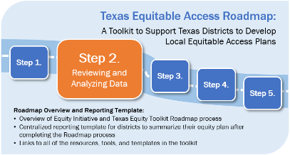
Step 2. Reviewing and Analyzing Data
The purpose of this step is to help you calculate your district’s equity gaps by assessing, analyzing, and communicating your district’s equitable access data. After conducting a review and analysis of your district data, you and your district stakeholders will have completed the following activities:
- Established definitions of effective teaching;
- Collected required data to calculate equity gaps for access by students of color and low-income students to effective teaching, inexperienced teachers, and out-of-field teachers; and
- Calculated required and optional equity gaps.

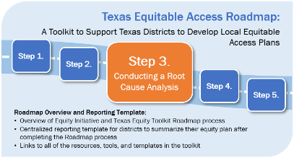
Step 3. Conducting a Root Cause Analysis
The purpose of conducting a root cause analysis (RCA) is to review data to identify possible root causes that have the greatest effect on inequitable access for low-income students and students of color to effective teaching, and inexperienced and out-of-field teachers. By the end of the process, you will have identified key root causes for the identified equity gaps in your district.

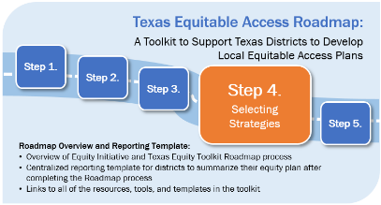
Step 4. Selecting Strategies
You and your district team will use the results of the data review and root cause analyses (Steps 2 and 3) to identify strategies that address district equitable access gaps. Step 4 will guide you through the process of developing and prioritizing strategies and activities most likely to address the root causes identified in Step 3.

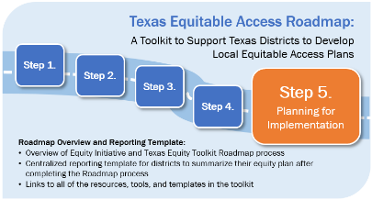
Step 5. Planning for Implementation
In the fifth and final step in the Texas Equitable Access Roadmap, you will have used the information generated from earlier activities, including data review and analysis (Step 2) and selecting strategies (Step 4) to develop a progress monitoring plan so you and your district can effectively evaluate and track progress toward equitable access.

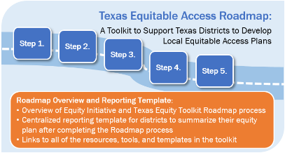
Putting It All Together: The Roadmap Reporting Template
The reporting template on the subsequent pages provides a space for you to report the key findings from each step of the Roadmap and report these findings to your ESC. The reporting template can be filled in by directly copying/pasting content from the Putting It All Together section of each step
of the toolkit.
For more information on the district equity plan submission, please visit the Texas Equity Toolkit website or reach out to the Equity Toolkit lead at your local ESC.

Putting It All Together: Roadmap Overview and Reporting Template

Instructions
Please complete each field below. A district leader or staffer who was strongly involved with the equity work your district undertook while completing the five tools of this toolkit should complete this template with the support from the overall equity planning team. Each section of the reporting template can be filled in by copying and pasting the information from the end of each step in the toolkit.
If you have any questions, please reach out to the Equity Toolkit lead at your local ESC.

District Reporting Template
District Name
County District Number (CDN)
Date
Name/E-mail of District Point Person

Results of Step 1. Engaging and Communicating with Stakeholders
Note that TEA does not require districts to report the outcomes of their stakeholder engagement planning. Your team may move forward to Step 2 to begin reporting the outcomes of your district’s equity plan development.

Results of Step 2. Reviewing and Analyzing Data
For this next set of items, please refer to the “Putting It All Together: Incorporating Your Reviewing and Analyzing Data Efforts Into Your Roadmap Reporting Template” from the Step 2. Reviewing and Analyzing Data tool. Please transfer the information from the end of Step 2 into the spaces below.
Districts with four or more campuses should complete Table A. Districts with three or fewer campuses should complete Table B. All districts also must respond to the two questions following Table B on your district’s definition of effective teaching.
Table A. Districts with Four or More Campuses—Reporting Template for Calculating Equity Gaps for Inexperienced and Out-of-Field Teachers
Row | Comparison | Percentages of:
 |  | Inexperienced Teachers | Out-of-Field Teachers
Equity Gap Calculations: Low-Income Students
A | High-poverty quartile
B | Low-poverty quartile
C | District equity gap: High-poverty quartile minus low-poverty quartile (row A–row B)
D | State averageª
E | State equity gap: High-poverty quartile minus state average (row A–row D)
Equity Gap Calculations: Students of Color
F | High-minority quartile
G | Low-minority quartile
H | District equity gap: High-minority quartile minus low-minority quartile (row F–row G)
I | State equity gap: High-minority quartile minus state average (row F–row D)
ª State averages for inexperienced and out-of-field teachers are available and updated annually on the TEA Equity Toolkit website.
Table B. Districts with Three or Fewer Campuses—Reporting Template for Calculating Equity Gaps for Inexperienced and Out-of-Field Teachers
 |  | Percentages of:
Row | Comparison | Inexperienced Teachers | Out-of-Field Teachers
A | Percentage of teachers in the Title I campus
B | State averageª
C | State equity gap: Title 1 campus minus state average (row A – row B)
ª State averages for inexperienced and out-of-field teachers are available and updated annually on the TEA Equity Toolkit website.

What is your district’s definition of effective teaching?
In the fields below, record the definitions of effective teaching according to the three categories included in the table. Provide a description of your rationale for these three definitions.
Our District’s Definition of Effective Teaching:
Teaching Performance | Student Learning | Student Engagement
Selected data to measure teaching performance: | Selected data to measure student learning | Selected data to measure student engagement:
Definition of effective teaching using these data | Definition of effective teaching using these data | Definition of effective teaching using these data
After examining the equity gaps in your district related to student access to effective teaching, what are your conclusions?

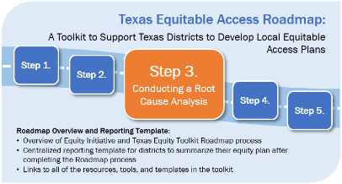
Results of Step 3. Conducting a Root Cause Analysis
For this next set of items, please refer to the “Putting It All Together: Incorporating Your Conducting a Root Cause Analysis Efforts Into Your Roadmap Reporting Template” section of your RCA tool and transfer the information to the following spaces.
Problem Statement:
Root Causes as They Relate to ATTRACTING Excellent Teachers | Root Causes as They Relate to SUPPORTING Excellent Teachers | Root Causes as They Relate to RETAINING Excellent Teachers

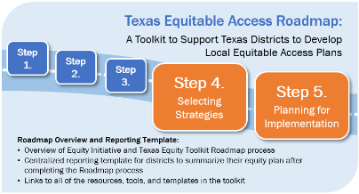
Results of Steps 4 and 5. Selecting Strategies and
Planning for Implementation
For this next set of items, please refer to the “Putting It All Together: Incorporating Your Selecting Strategies Efforts Into Your Roadmap Reporting Template” section of your Selecting Strategies tool and Planning for Implementation tool.
Complete the following tables by first listing your district’s long-term outcomes. These are your high-level goals that should occur in the next 2–5 years if your strategies are successful. Then, list the strategies your district will implement to address the root causes of the equity gaps in your district.
Long-Term Outcomes (from Step 5):

Identified Root Cause  (from Step 3) | Selected Equity Plan Strategies  (from Step 4) | Outputs  Benchmark 1  (from Step 5) | Short-Term Outcome  Benchmark 2  (from Step 5) | Mid-Term Outcome  Benchmark 3  (from Step 5)

Use this box to provide any additional insights you learned from completing this process or provide any additional information you think is necessary to understanding your plan.

Appendix
List of Resources to Support Local Equity Plan Development, by Topic Area
Topic Area | Resource and Link to Access Resource
Every Student Succeeds Act (ESSA) | - Information from the U.S. Department of Education (ED) (http://www.ed.gov/essa?src=rn).  - Information on equity as it relates to states is included in section (1111(g)(1)(B)).  - Information on equity as it relates to districts is included in section (1112(b)(2)).
Equity Plans | - State Equity Plans—plans submitted by all of the states to ED in 2015 (https://www2.ed.gov/programs/titleiparta/resources.html).  - Texas 2015 Equity Plan (http://tea.texas.gov/About_TEA/Laws_and_Rules/NCLB_and_ESEA/Title_I,_Part_A_-_Improving_Basic_Programs/State_Plan_To_Ensure_Equitable_Access_to_Excellent_Educators/).
Engaging and Communicating with Stakeholders | - The Center on Great Teachers and Leaders (GTL Center) has developed sample stakeholder engagement meeting agendas for various formats (http://www.gtlcenter.org/sites/default/files/GTL_Resource_04_Agendas-ed-fmt.doc).  - Communications planning resource from the GTL Center (http://www.gtlcenter.org/sites/default/files/Communication_Guidebook.pdf).  - Developing key messages—Ideas and suggestions from the GTL Center (http://www.gtlcenter.org/sites/default/files/Communication_Guidebook.pdf).  - Gathering stakeholder feedback with a feedback form from the GTL Center that districts can use or repurpose (http://www.gtlcenter.org/sites/default/files/GTL_Resource_05_IncorpFeedback-ed-fmt.doc).
Reviewing and Analyzing Data | - ED definition of “out-of-field” teachers (https://www2.ed.gov/policy/elsec/leg/esea02/pg20.html).  - Best practices in defining an “ineffective” teacher. Resource from the GTL Center Teacher Effectiveness in the Every Student Succeeds Act: A Discussion Guide (http://www.gtlcenter.org/sites/default/files/TeacherEffectiveness_ESSA.pdf).  - The reference above also helps guide consideration of the role district resources, including time, money, and educator engagement, play in the decision-making process in defining effective teaching.  - Texas Data Checklist (list of data elements available to most districts in Texas; LINK TBD).  - Data from the Public Education Information Management System (PEIMS) (2015–2016) sources. Code tables available at http://ritter.tea.state.tx.us/peims/standards/weds/.  - Definition of person of color—New Oxford American Dictionary (2015) definition is a person of color is a person who is not White or of European parentage (https://en.oxforddictionaries.com/definition/us/person_of_color).  - The PEIMS 110 record includes an “at-risk indicator code.” This code indicates whether a student is currently identified as at-risk of dropping out of school using state-defined criteria that are based on whether the student meets one or more of 13 criteria. For more information, please visit http://ritter.tea.state.tx.us/peims/standards/weds/.  - Chronic absenteeism refers to excessive absences during the school year while truancy refers to a certain number or certain frequency of unexcused absences. In Texas, chronic absenteeism generally refers to a student who is absent for 10% or more of the days school is offered (see Texas. Education Code §25.092; http://www.statutes.legis.state.tx.us/?link=ED). Truant conduct is defined as failing to attend school without an excuse on 10 or more days or parts of days within a 6-month period in the same school year (see Texas Family Code §65.003(a); http://www.statutes.legis.state.tx.us/Docs/FA/htm/FA.65.htm).  - Research on within campus inequitable student access to effective teachers—Goldhaber, D., Lavery, L., & Theobald, R. (2014). Uneven playing field? Assessing the inequity of teacher characteristics and measured performance across students (CEDR Working Paper 2014-14). Seattle: University of Washington. Retrieved from http://www.cedr.us/papers/working/CEDR%20WP%202014-4.pdf.
Conducting a Root Cause Analysis | - Problems of Practice Related to Talent Management—As districts explore the root causes of their equity gaps, it may be helpful to carefully examine current talent management strategies, policies, and practices and consider how they may be supporting or hindering equitable access. The following GTL Center resources and tools can help districts as they consider how their current approaches support attracting, supporting, and retaining excellent educators in their highest need campuses.  - Talent Development Framework (http://www.gtlcenter.org/sites/default/files/14-2591_GTL_Talent_Dev_Framework-ed_110714.pdf).  - Creating Coherence and Alignment Tool (http://www.gtlcenter.org/sites/default/files/Coherence_Alignment_Tool.pdf).  - Talent Management Strategies: Districts Self-Assessment Checklist (https://easn.grads360.org/#communities/pdc/documents/12611).  - After conducting a root cause analysis, districts may want to collect feedback from participants/stakeholders. Your district may develop its own feedback form, or you could choose to use or adapt an existing feedback form like the one developed by the GTL Center available at http://www.gtlcenter.org/sites/default/files/GTL_Resource_05_IncorpFeedback-ed-fmt.doc.
Selecting Strategies | - How to select strategies to address equity gaps—The GTL Center’s Research-Supported Implementation Tips for Equitable Access Plan Strategies resource (http://www.gtlcenter.org/sites/default/files/Implementation_Tips.pdf).  - Reviewing existing strategies may prompt some districts to consider a more comprehensive review of the alignment and coherence of their district’s policies and practices. The resources below can assist those efforts.  - Talent Development Framework (http://www.gtlcenter.org/sites/default/files/14-2591_GTL_Talent_Dev_Framework-ed_110714.pdf).  - Creating Coherence and Alignment Tool (http://www.gtlcenter.org/sites/default/files/Coherence_Alignment_Tool.pdf).  - Talent Management Strategies: Districts Self-Assessment Checklist (https://easn.grads360.org/#communities/pdc/documents/12611).
Planning for Implementation | - Developing a logic model. Although a formal logic model is not required when planning for implementing your district strategies, it might be helpful to create one, especially if you are using many strategies. Logic model development resources are available from:  - The Kellogg Foundation (https://www.wkkf.org/resource-directory/resource/2006/02/wk-kellogg-foundation-logic-model-development-guide).  - Regional Education Laboratory Northeast and Islands (http://www.relnei.org/events/skill-builder-archive/logic-model-to-program-evaluation.html).  - If you need help generating a list of common barriers, you can refer to the GTL Center’s Monitoring Tool for a list of common barriers (http://www.gtlcenter.org/sites/default/files/Monitoring_Tool.pdf).

For more information on the Every Student Succeeds Act, visit http://www.ed.gov/essa?src=rn. Information on equity as it relates to states is included in section (1111(g)(1)(B)). Information on equity as it relates to districts is included in section (1112(b)(2)).

